BOARD DECISION / SEPTEMBER 2026

Approve a staged
growth plan.
Protect the $150,000 operating reserve. Release acquisition and hiring in steps while testing retention.
To: Northstar Field Notes board | From: Planning team | Decision date: 2 September 2026
Every company detail, record and assumption is fictional. This memo demonstrates an operating decision process; it contains no real company financials or market estimates.

Why this is the decision
The base plan ends with 6,923 members and $754,424 of cash. The more relevant constraint is its $176,348 low point in Apr 2027: only $26,348 above the reserve. A profitable third year does not make every route to it affordable.

Stage acquisition
Approve an initial $26,325 monthly budget, with the modeled 6% annual ramp. Do not authorize the 2x plan now. It adds 2,629 members at month 36, but lowers the cash trough to $52,831. The planning lead should refresh the cash forecast monthly; the board can revisit expansion when the trough remains above $150,000 and monthly-plan churn is at or below 3.5% for two months.

Fund a measured retention test
Authorize $7,500 for the next 90 days from the $2,500 monthly program already in the plan. Member operations should test onboarding, cancellation interviews and useful member programming. Continue only after two cohorts have matured enough to compare churn and engagement; do not treat the model sensitivity as a proven program return.

Hire against demand, with a cash review
Approve the role plan conditionally: community success at 3,600 members, no earlier than month 7; a half-time event producer at 5,500, no earlier than month 16. Before signing each hire, the publisher should rerun the forward cash curve and preserve the $150,000 floor. These are decision gates; the model itself does not automatically stop hiring.
Evidence: Scenarios; Sensitivity; Staffing; Plan rows 88-101. Owners named here are fictional operating roles.
ECONOMICS / EARNINGS AND CASH

The first-year loss
is visible and funded.
The base plan earns $1,210,184 in year one and records a pretax operating loss of ($121,628). Cash declines by only $52,585, because annual subscriptions collect cash before the service is fully delivered.
Fiscal year to August | Revenue | Pretax income | Closing cash | Members
2027 | $1,210,184 | ($121,628) | $194,825 | 4,601
2028 | $1,676,739 | $143,740 | $393,506 | 5,914
2029 | $1,989,931 | $316,189 | $754,424 | 6,923
Workbook: Scenarios, Base columns. All amounts USD; forecast members are expected values.

The cash bridge is an obligation, not extra profit
Year 1 cash reconciliation | USD
Opening cash | $247,410
Pretax operating income | ($121,628)
Increase in annual deferred revenue | $69,043
Net event deferral / vendor prepaid change | $0
Closing cash | $194,825
The bridge sums opening cash, pretax income and timing changes. Annual deferred revenue closes year one at $171,783. Quarterly events fall at year end, leaving no event deposit or vendor prepaid balance at that cutoff.

The forecast cost reset is deliberate
The launch budget is 1.5x August spend, while base CAC is 1.55x observed channel CAC to stress the expanded audience. Existing loaded payroll rises from $24,000 to $30,600 a month; editorial support rises from $4,200 to $6,000; overhead rises from $5,600 to $9,500. Member delivery moves from $3.20 to $5.00 per member, and the $2,500 retention program is new. These changes explain the first-year margin reset.
An $18,000 platform setup is paid and expensed once in September 2026. Hire onboarding costs $4,000 per new FTE; recurring payroll is separate. No capitalization or financing inflow is assumed.
Trace: History → Assumptions → Plan revenue (35-40), expenses (43-74), cash (77-101).
GROWTH / THE ALLOCATION TRADEOFF

Twice the acquisition.
Little extra ending cash.
Doubling acquisition increases three-year spend by $1,033,065. It lifts month-36 membership by 2,629, but ending cash improves by only $28,072. The reserve is crossed in December 2026, well before the business reaches its larger member base.
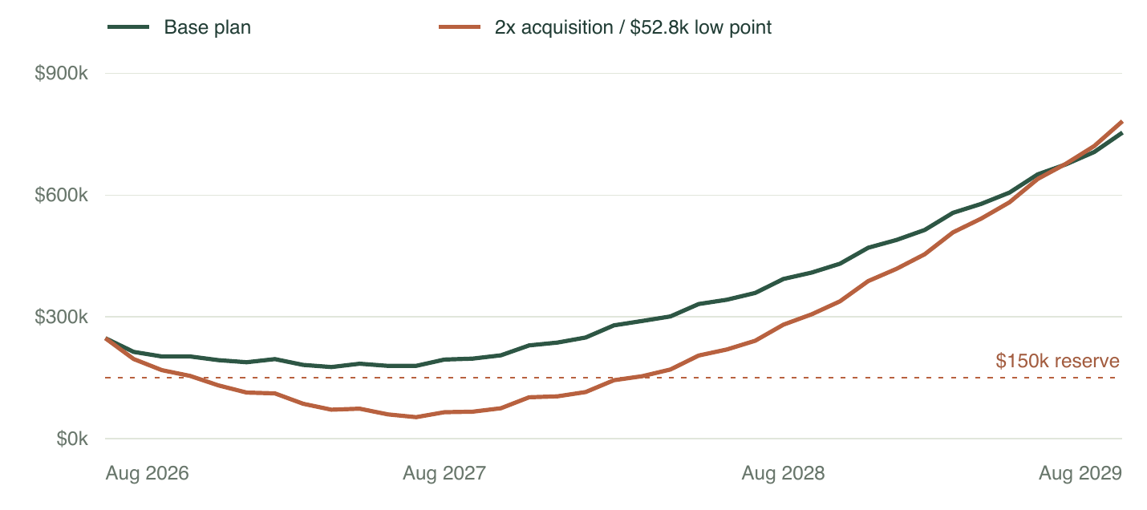
Monthly closing cash, including the August 2026 opening balance. The dashed line is the $150,000 reserve. Both plans use 3.6% monthly churn and 74% annual renewal.
Controlled comparison | Base | 2x acquisition | 2.6% churn
Month 36 members | 6,923 | 9,552 | 7,769
Minimum cash | $176,348 | $52,831 | $191,106
Month 36 cash | $754,424 | $782,495 | $1,029,205
Sensitivity: all other Base drivers held fixed. The lower-churn case changes monthly-plan churn only.

Use the retention sensitivity to size a test
At unchanged acquisition spend, reducing monthly churn from 3.6% to 2.6% adds $274,781 to ending cash and 846 members. That is the value of a hypothetical operating improvement, not an estimated causal return on the retention program. Annual renewal remains 74%, and delivery and hiring costs still rise with the larger audience.
The downside of a failed test is $7,500 over 90 days; the model does not assume that spending this amount guarantees any churn reduction.
RISK / ACTION BEFORE THE SHORTFALL

Use the reserve breach
as an early warning.
The downside case combines 5.0% monthly churn, 64% annual renewal, more expensive acquisition, weaker organic adds and event demand, and a three-month delay to optional hiring. It crosses the reserve in Mar 2027, runs short of cash in Jun 2028, and reaches a peak unfunded gap of $81,124.
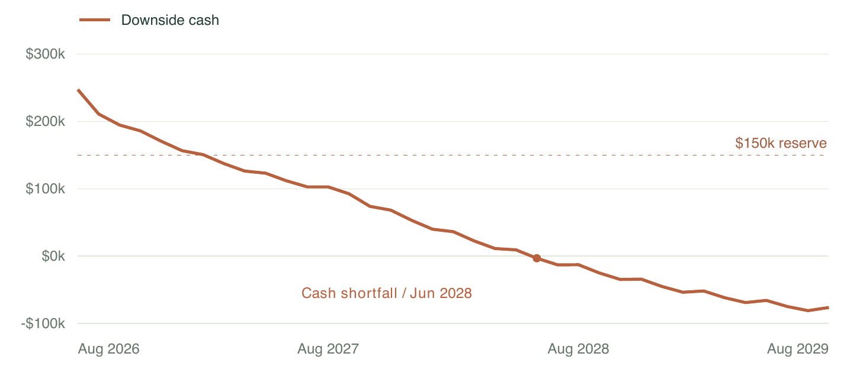
Downside closing cash. Negative balances are unfunded requirements; the model keeps operations running to expose the gap. No automatic borrowing or emergency cuts are inserted.

A monthly decision rhythm
- Planning lead: update acquisition CAC, churn and the 12-month cash view each month. If a projected close falls below $150,000, pause uncommitted expansion and present a resized plan before the next spending release.
- Member operations: track monthly-plan churn against the 3.5% gate for two consecutive months. Assess annual renewal separately; avoid interpreting one good month or mixed payment-plan churn as evidence of retention improvement.
- Publisher: confirm demand and cash before each optional hire. In Base, community success starts in Mar 2027 and the half-time event producer starts in Apr 2028. Hiring creates persistent payroll, even if growth later slows.

Risks the board should keep open
The model assumes stable prices, no refunds and no event cancellations. It also omits taxes, debt and receivable delays. Annual prepayments support cash while creating future service obligations. The reserve and the scenario spreads are management choices, not confidence intervals. Refresh these assumptions before using the structure with real records.
METHOD / TRACEABILITY AND LIMITS

Every conclusion has
a path back to inputs.

Generated inputs
Fictional exports cover membership, acquisition, product mix, annual billing and staffing. Acquisition arrives as 38 records with two identical duplicates, three date formats, currency strings and six channel aliases. Stable record IDs yield 36 unique channel-month rows. Churn is recomputed from opening members and cancellations; no missing observations are filled.

Connected equations
Channel spend divided by CAC creates paid members; organic adds remain separate. New members split into monthly and annual plans. Monthly cohorts decay each month. Annual contracts renew only at anniversaries, seeded by the opening billing cohorts. Expected members drive revenue, delivery costs, event demand and hiring.
Annual subscriptions pay upfront and earn revenue over 12 months. Events collect a 30% deposit and pay a 40% vendor deposit one month early. Revenue and event expenses are recognized at delivery. Cash, deferred revenue, vendor prepaids and book equity roll forward separately and reconcile.

Independent audit
A separate Python cohort ledger agrees with JavaScript, all four workbook plan tabs and the nine-case sensitivity grid. All 46,213 formulas have cached values; there are no error cells. Across 5,028 numeric comparisons, the maximum difference is 1.7e-09, below a $0.00001 tolerance. Input-change tests cover doubled acquisition, lower churn and reset.

Limits and revision
This pretax operating model excludes taxes, debt, interest, capex, distributions, receivables/payables, refunds, layoffs and statistical uncertainty. Annual price stays at $240; repricing requires a contract-price ledger. The 36-month horizon and 12-month contract term are structural constants. Hires persist after activation, with no automatic cash freeze; event capacity is fixed.
Cases are illustrative, without assigned probabilities. Retention spending does not guarantee improvement. “36 funded months” means only that no shortfall appears within this forecast. Regenerate the static memo and briefing after changing assumptions.
Audit path: Board → Assumptions → Plan → Cohorts / Acquisition / Opening Cohorts / Staffing. Scenarios and Sensitivity Engine expose the alternatives. The local source pack includes original records, normalized data, code, verification receipts and reproduction commands.

